**ASSIGNMENT - 2**

( Module – 2)

1. What is software Testing?

* Software testing is process used to identify the correctness, completeness and quality of developed computer software.

1. What is Exploratory Testing?

* Exploratory testing is functionalities are checked in a ad -hoc manner.

1. What is traceability matrix?

* Traceability matrix is a table which is used to trace the requirement during the SDLC. It can be used for forward tracing or backward.

1. What is Boundary value testing?

* Boundary value is methodology for designing test cases that concentrates software testing effort on cases near the limits of valid ranges.

1. What is Equivalence partitioning testing?

* The number fall into a partition where each would have the same or equivalent result.

1. What is Integration testing?

* Testing performed to expose defect in the interface and interaction between integrated components or system.

1. What determines the level of risk?

* ‘A factor that could result in future negative consequences; usually expressed as impact and likelihood’

1. What is Alpha testing?

* Alpha testing is performed at the time of Acceptance testing when developers test the product and project to check whether it meets the user requirement or not.
* It always performed by the developers and it is not open to the market and public.

1. What is beta testing?

* Beta testing is always performed at the time when software product and project are marketed.
* It is always performed by customers and it is always open to the market and public.

1. What is component testing?

* A minimal software item that can be tested in isolation.
* The testing of individual software component.

1. What is functional system testing?

* A requirement that specifies a function that a system or system component must perform.

1. What is Non-Functional Testing?

* Testing of those requirements that do not relate to functionality.

1. What is GUI Testing?

* Graphical User Interface (GUI) testing is the process of testing the system’s GUI of the System under Test. GUI testing involves checking the screens with the controls like menus, buttons, icons, and all types of bars – tool bar, menu bar, dialog boxes and windows etc.

1. What is Ad-hoc testing?

* Ad hoc testing is an informal testing type with an aim to break the system.

1. What is white box testing and list the types of white box testing?

* Testing based on an analysis of the internal structure of the component or system.

1. What is black box testing? What are the different black box testing techniques?

* Testing either functional or non functional , without reference to the internal structure of the component or system.
* A) Equivalence partitioning
* B) Boundary value analysis
* C) Decision table
* D) State transaction testing
* E) Use case testing
* F) Syntax or pattern testing

1. Mention what are the categories of defects?

* A) Data Quality/Database Defects
* B) Critical Functionality Defects
* C) Functionality Defects
* D) Security Defects
* E) User Interface Defects

1. Mention what big bang testing is?

* Big Bang integration testing all components or modules is integrated simultaneously, after which everything is tested as a whole.

1. What is the purpose of exit criteria?

* Purpose :- exit criteria is to define when we stop testing.
* End of all testing
* End of phase of testing

1. When should "Regression Testing" be performed?

* when the system is stable and the system or the environment changes.
* when testing bug-fix releases as part of the maintenance phase.
* It should be applied at all Test Levels

1. What is 7 key principles? Explain in detail?

A) testing shows presence of defect :- testing show that defects are present, but cannot prove there are no defects.

* We test to find defects.

B) Exhaustive testing is not possible :- Testing include everything all combination of inputs and precondition is not possible.

- We have learned that we cannot test everything.

C) early Testing :- Testing is start as early as possible on the software or system development life cycle focused on defined objectives.

D) defect clustering : - A small number of modules contain most of the defects discovered during pre- release testing.

- Defect are not evenly spread in system.

E) the pesticide paradox :- if the same test are repeated over and over again , eventually the same set of test case will no longer find any new defects.

- Regularly reviewed and revised and new and different test cases need to be written and potentially find more defects.

F) testing is context dependent :- Testing is basically context dependent.

* Testing is done differently in different contexts.
* Different kinds of sites are tested differently.

G) absence of error fallacy :- If the system built is unusabale as does not does not fulfil the user’s needs and expectations the finding and fixing defect does not help.

1. Difference between QA v/s QC v/s Tester

|  |  |  |
| --- | --- | --- |
| **QA** | **QC** | **TESTER** |
| Focuses on process | Focuses on actual testing | Focuses on actual tsting |
| Process oriented activities | Product oriented activities | Product oriented activities |
| Preventive activities | Corrective process | Preventive process |
| Subset of STLC | Subset of QA | Subset of QC |

1. Difference between Smoke and Sanity?

|  |  |
| --- | --- |
| SMOKE TESTING | SANITY TESTING |
| Smoke Testing is performed to ascertain that the critical functionalities of the program is working fine. | Sanity Testing is done to check the  new functionality / bugs have been fixed. |
| Performed by developers or tester. | Performed by only testers. |
| It is documented or scripted. | It is undocumented or un scripted. |
| It is subset of regression testing. | It is subset of Acceptance testing. |
| It is General health check up. | It is specialize health check up. |

1. Difference between verification and Validation

|  |  |
| --- | --- |
| **VERIFICATION** | **VALIDATION** |
| It is before the coding. | It is after the coding. |
| It is static testing. | It is dynamic testing. |
| It is development level. | It is testing level. |
| 1. Business 2. System requirements 3. Technical specification 4. Program specification | 1. Acceptance testing 2. System testing 3. Integration testing 4. Unit testing |

1. Explain types of Performance testing.

* A) Load testing
* B) Stress testing
* C) Volume testing
* D) Spike testing
* E) Endurance testing
* F) Scalability testing

1. What is Error, Defect, Bug and failure?

**Error** :- Developer mistake in coding it is called error.

**Defect** :- Error found by tester it is called Defect.

**Bug** :- Defect accept by development team it is called Bug.

**Failure** :- Does not meet specified customer requirements.

1. What is Bug Life Cycle?

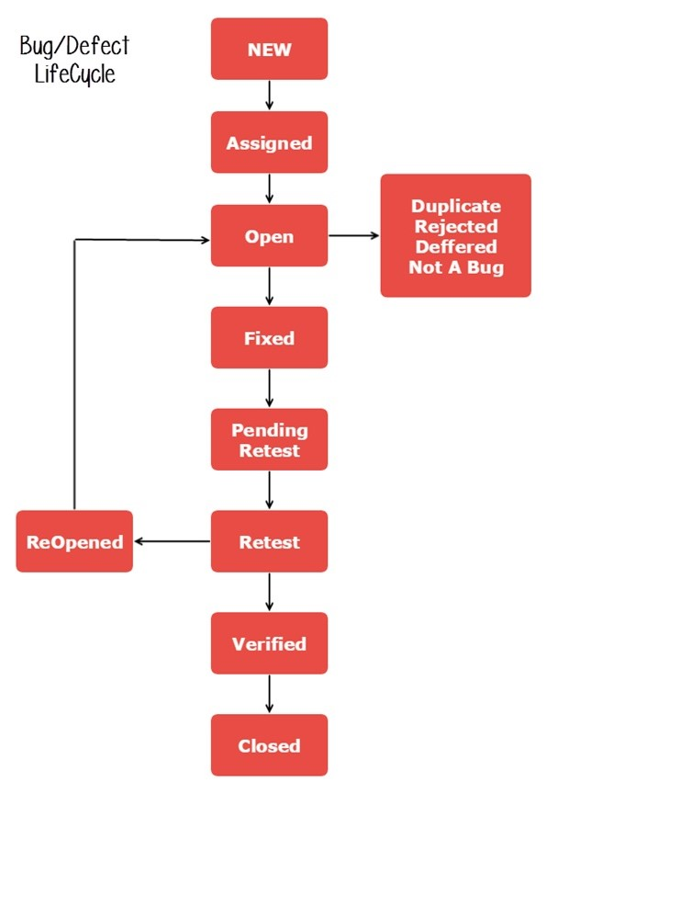

1. Explain the difference between Functional testing and NonFunctional testing

|  |  |
| --- | --- |
| FUNCTIONAL TESTING | NON- FUNCTIONAL TESTING |
| It is executed first. | It is executed after functional testing. |
| Easy to do manual testing. | Tough to do manual testing. |
| Manual testing and automation tools used for functional testing. | Using tools will be effective for this testing. |
| Types of functional testing   * Smoke testing * Sanity testing * Unit testing * Integration testing * Regression testing * Whitebox testing | Types of non – functional testing.   * Load testing * Stress testing * Volume testing * Performance testing * Security testing * Installation testing |

1. What is the difference between the STLC (Software Testing Life Cycle) and SDLC

|  |  |
| --- | --- |
| **SDLC** | **STLC** |
| It full form is software development life cycle | It full form is software testing life cycle |
| SDLC is structure imposed on the developed software that defines process testing, implementation,performance. | STLC is process always start with planning and close with test closure activities. |
| SDLC have six phases.   1. Requirement Collection 2. Analysis 3. Design 4. Implementation 5. Testing 6. Maintenance | STLC have five phases.   1. Test planning and controlling 2. Test analysis and designing 3. Test Implementation and execution 4. Evaluating exit criteria and Reporting 5. Test closure activities |

1. **What is the difference between test scenarios, test cases, and test script?**

* Test Scenarios is any functionality that can be tested.
* Test case involves set of steps, condition and input which can be used while performing the testing task.
* Test Script is specified the sequence of action for a test.

1. **Explain what Test Plan is? What is the information that should be covered?**

* Test plan is a high level document in which how to perform testing is described.

**A test plan will include the following,**

* Introduction to the Test Plan document.
* Assumptions when testing the application.
* List of test cases included in testing the application.
* List of features to be tested.
* What sort of Approach to use when testing the software.
* List of Deliverables that need to be tested.
* The resources allocated for testing the application.
* Any Risks involved during the testing process.
* A Schedule of tasks and milestones as testing is started.

1. **What are the different Methodologies in Agile Development Model?**

There are mostly two types of different methodologies use in agile development model,

* Scrum:- SCRUM is an agile development method which concentrates particularly on how to manage tasks within a team based development environment. Basically, Scrum is derived from activity that occurs during rugby match.
* eXtreme Programming :- This is a light weight agile testing methodology in which development and testing happen in parallel. Business requirements are gathered in terms of stories.

1. **Explain the difference between Authorization and Authentication in Web testing.**

* Authorization is accessibility to pages through permission not given.
* Authentication is accepting an invalid username/password.

1. **What are the common problems faced in Web testing?**

The tests performed on these types of applications would be,

* Usability Testing.
* GUI Testing means User Interface Testing.
* Functionality Testing.
* Security Testing
* Browser Compatibility Testing.
* Performance Testing.
* Load Testing.
* Stress testing.
* Interoperability Testing / Intersystem Testing.
* Volume Testing means Storage and Data Volume Testing.
* Database Testing means SQL Queries.